**Operating Systems – Lab 01**

**Name:** Hafsa Salman

**Roll no.** 22K-5161

**Task no. 01**

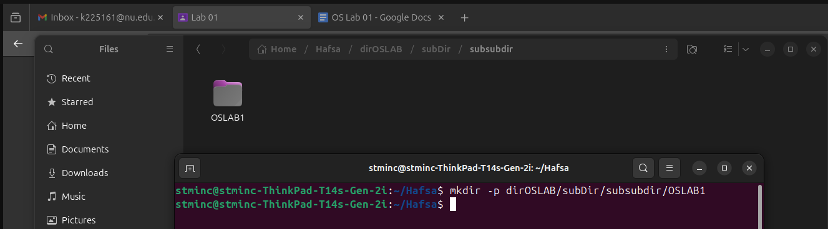



**Task no. 02**

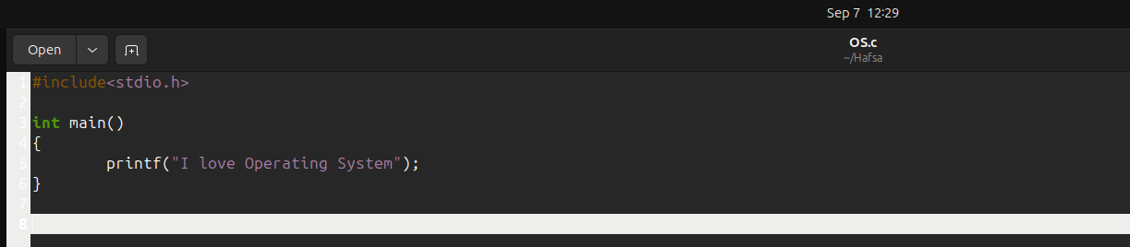

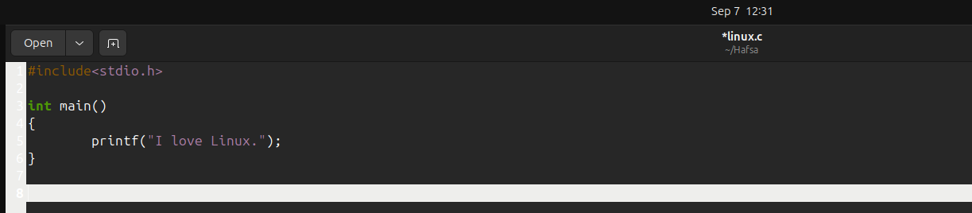

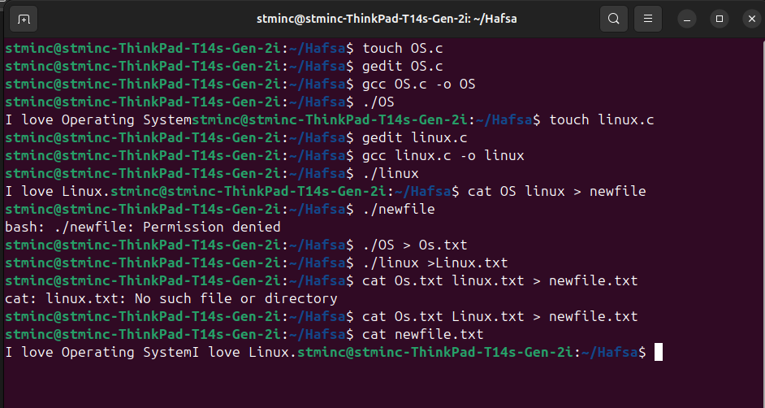

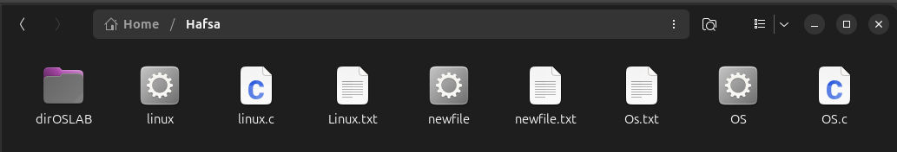

**Task no. 03**

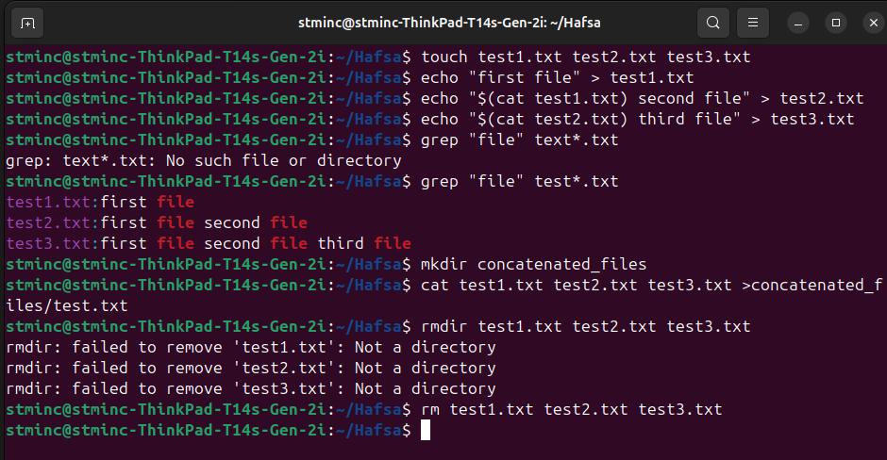

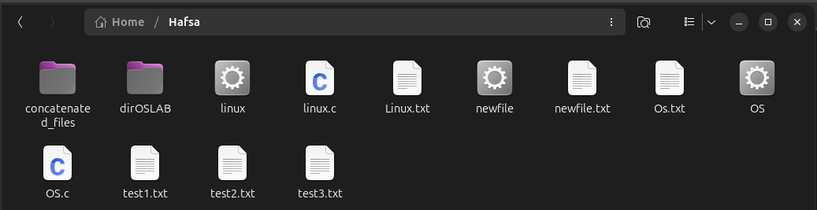

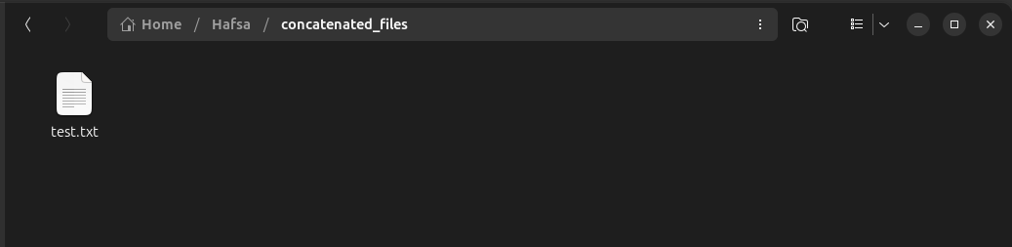

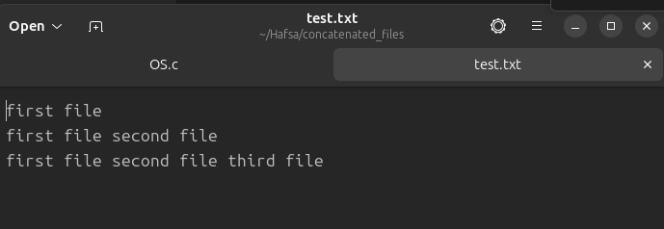

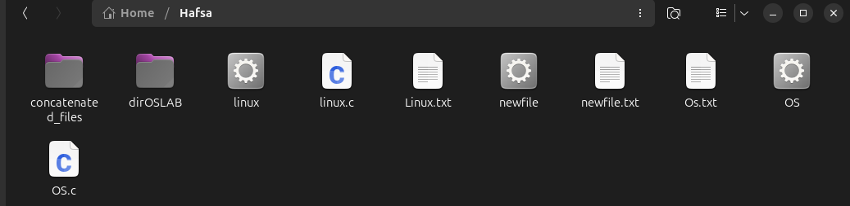

**Task no. 04**

